NUnit Test -> verifying data using an ADO connection

1]AddProduct

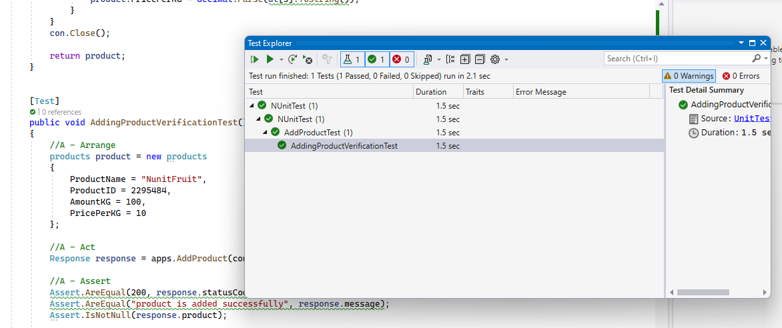

Double check with MySQL

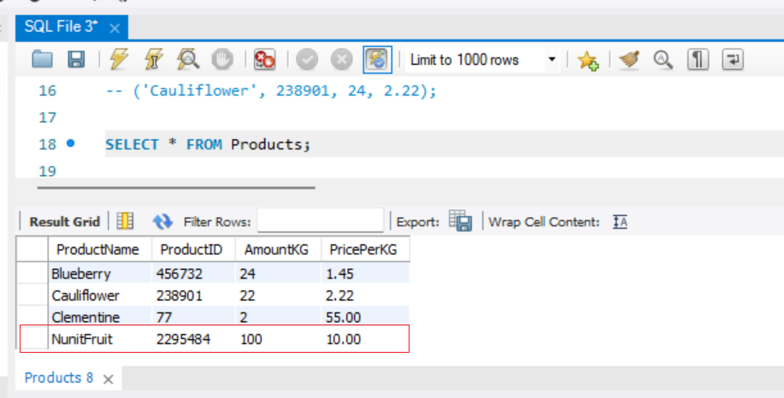

Test using REST API

“GetAllProducts” method successfully retrieved “NunitFruit”

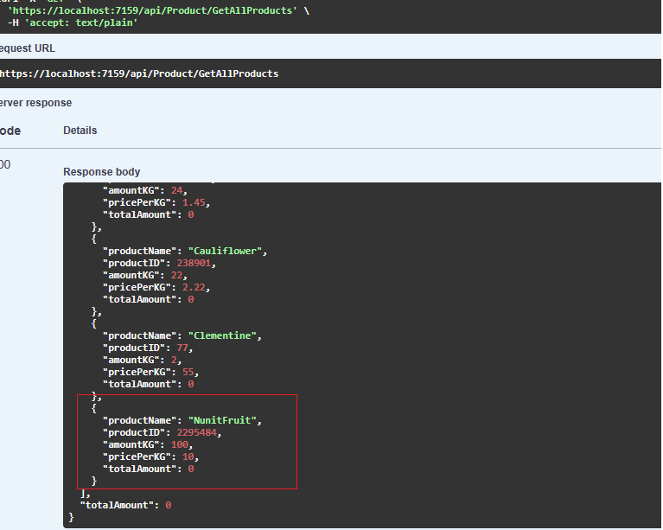

Test result

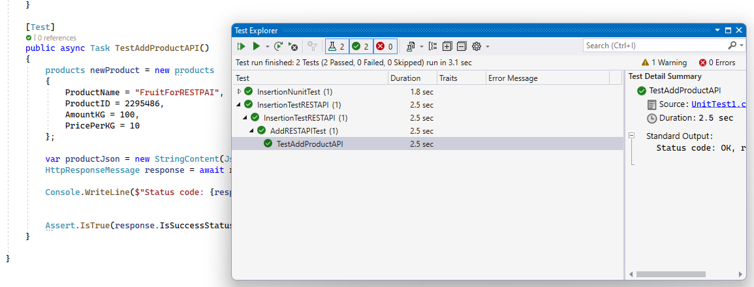

Double check with browser

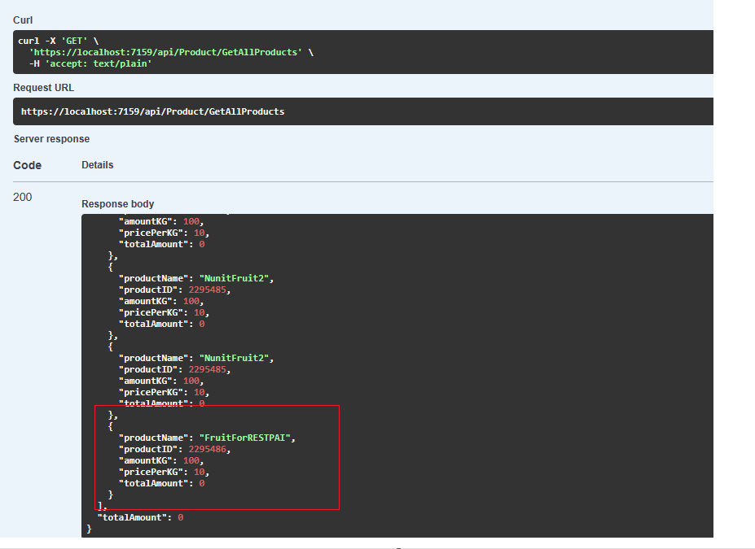

NUnit Test -> verifying if data is updated using an ADO connection

2]UpdateProduct

Currently productName is NunitFruit with PricePerKG is $10.00

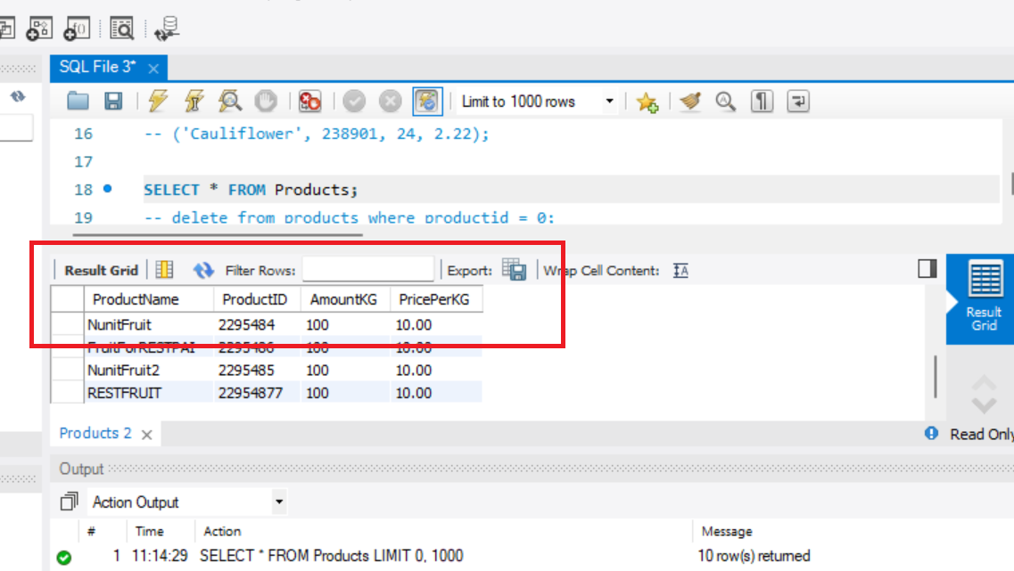

Test passed

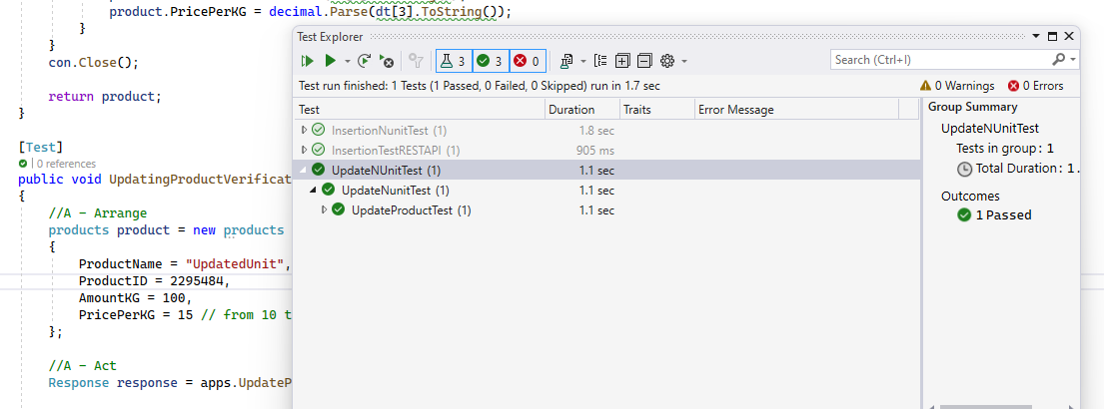

Updated

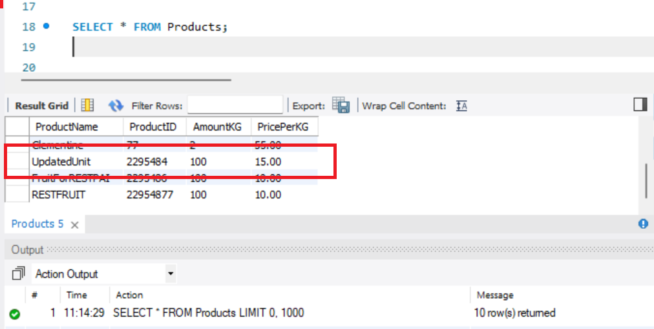

Test using REST API

Fetch product first that needs to be updated

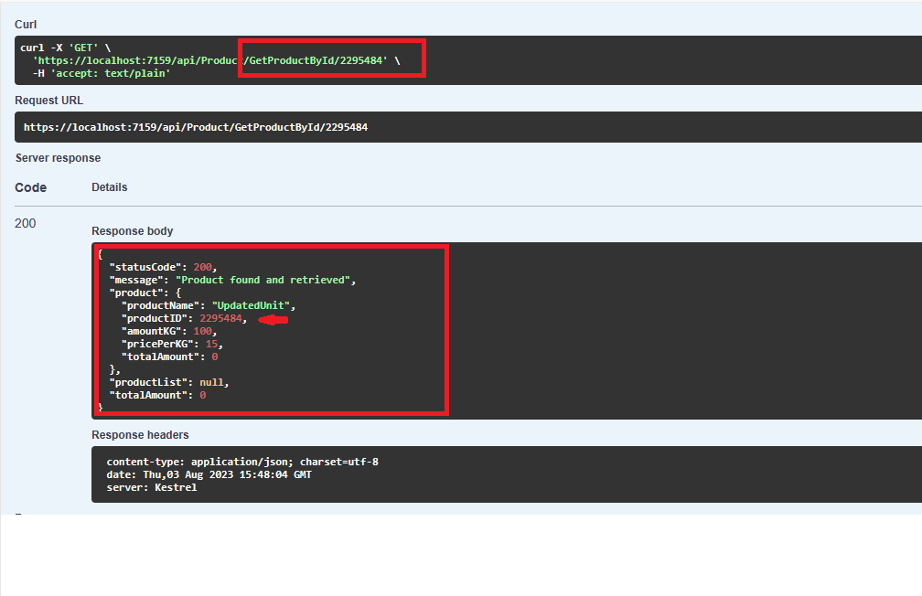

Test passed

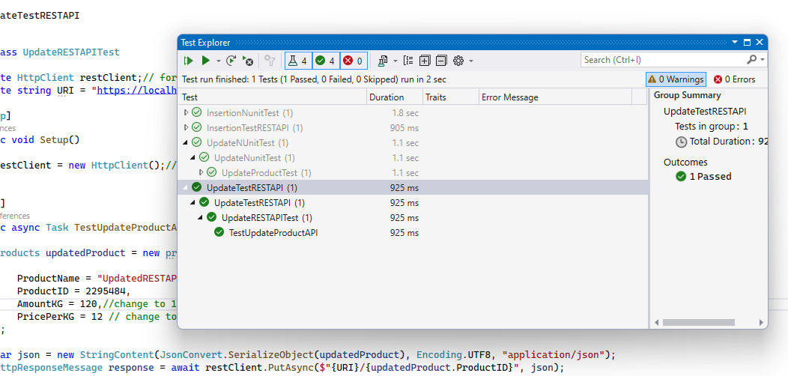

Updated on browser

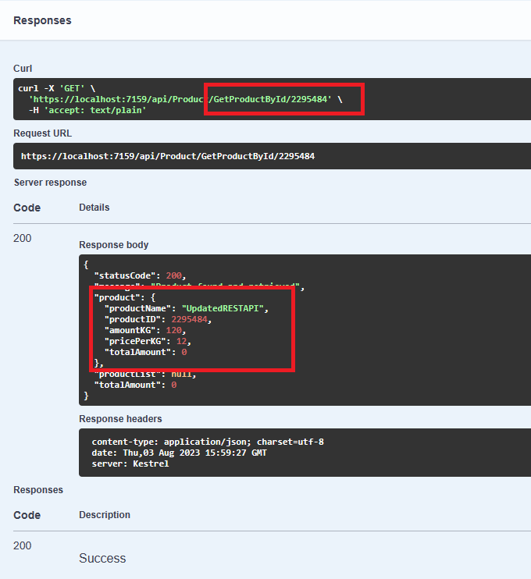

Updated on MySQL

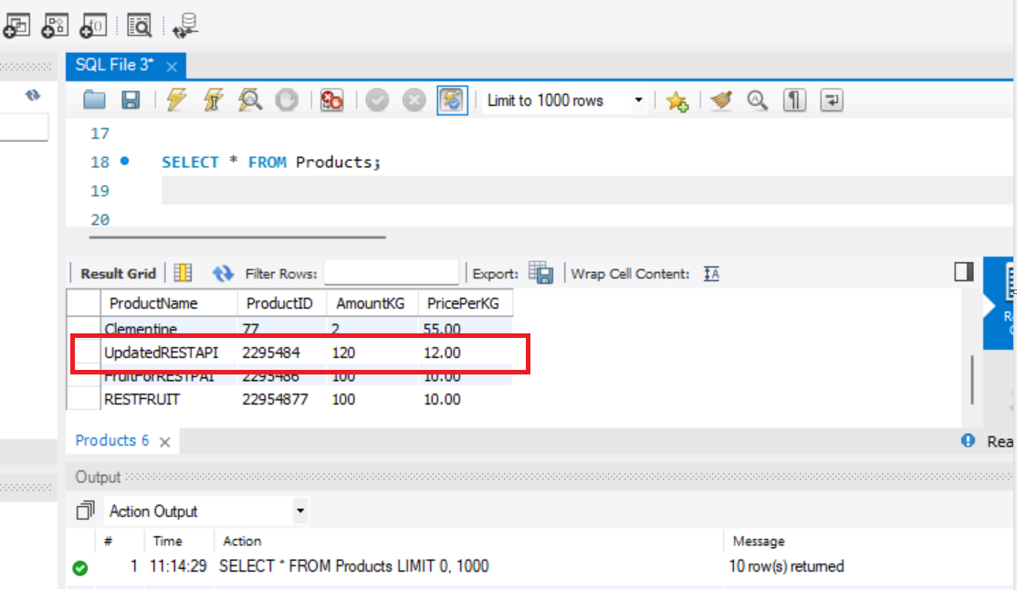

NUnit Test -> verifying if data is deleted using an ADO connection

3]DeleteProduct

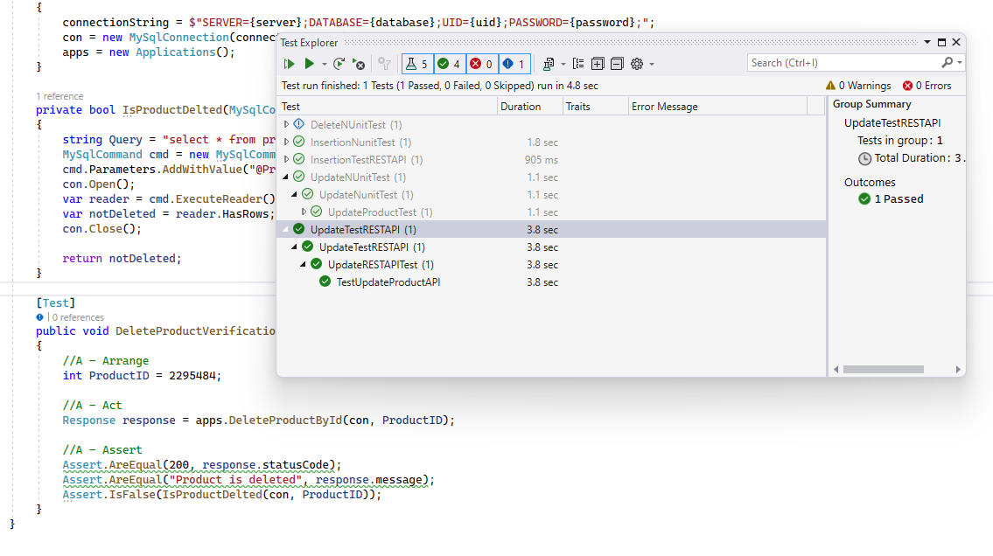

ID# 2295484 does not exist in MySQL

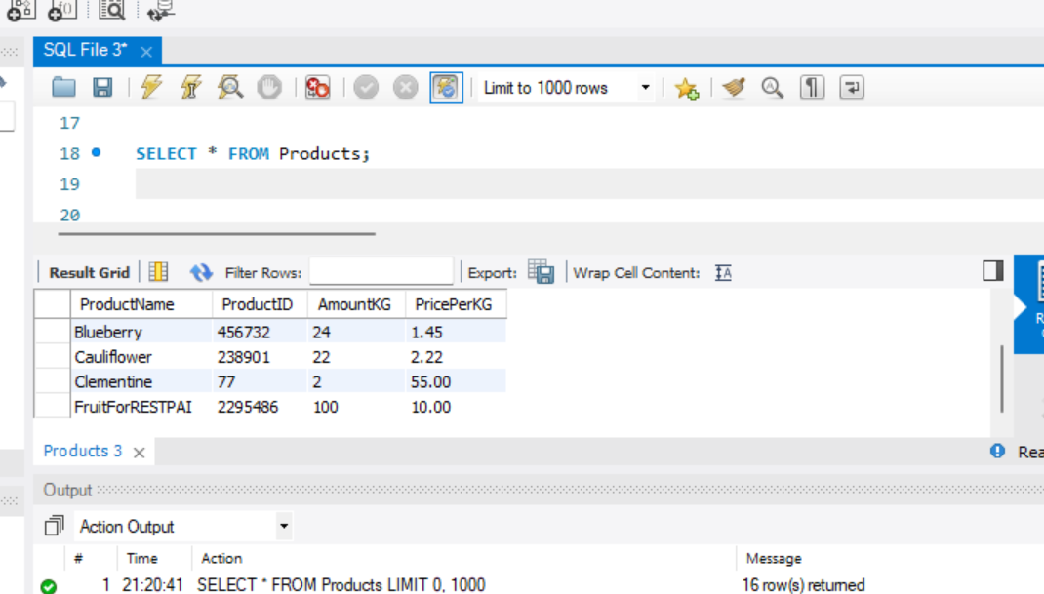

Test using REST API

Delete productId # 2295486

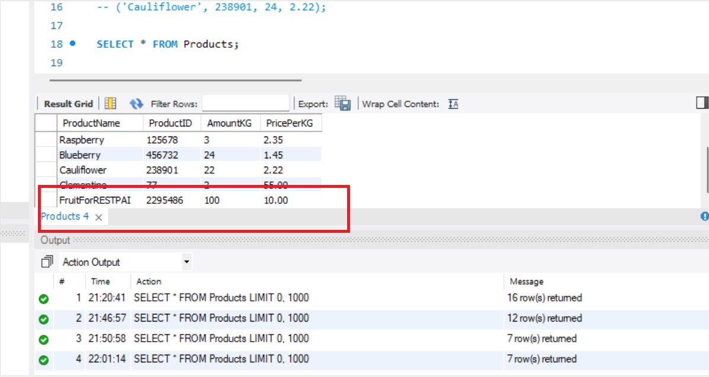

Test Passed

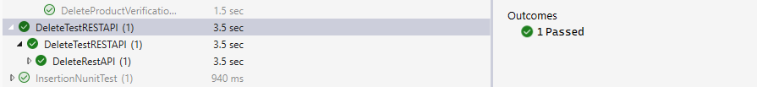

Unable to fetch id# 2295484 as it is deleted

